**UEFA CHAMPIONS LEAGUE 2021 – 22 PLAYER AND ANALYSIS REPORT**

About UEFA Champions League

The UEFA Champions League is an annual club football competition organised by the Union of European Football Associations and contested by top-division European clubs, deciding the competition winners through a round robin group stage to qualify for a double-legged knockout format, and a single leg final.

Introduction

The 2022 UEFA Champions League Final was the final match of the 2021–22 UEFA Champions League, the 67th season of Europe's premier club football tournament organised by UEFA, and the 30th season since it was renamed from the European Champion Clubs' Cup to the UEFA Champions League. It was played at the Stade de France in Saint-Denis, France, on 28 May 2022, between English club Liverpool and Spanish club Real Madrid. It was the third time the two sides have met in the European Cup final, after 1981 and 2018, the third final held here, after the 2000 and 2006 finals, and the first time the same two teams have met in three finals.

Real Madrid won the match 1–0 via a 59th-minute goal from Vinícius Júnior for a record-extending 14th title, and their 5th in nine years. As the winners of the 2021–22 UEFA Champions League, Real Madrid earned the right to play against the winners of the 2021–22 UEFA Europa League, Eintracht Frankfurt, in the 2022 UEFA Super Cup. Additionally, the winners typically qualify for the annual FIFA Club World Cup. However, the tournament's status remains uncertain, following FIFA's proposal for a format overhaul.

TABLE OF CONTENT

1. NUMBER OF GOALS SCORED PER CLUB (PLOT A GRAPH)

2. AVERAGE PLAYING TIME PER PLAYER PER CLUB (PLOT A GRAPH)

3. PLOT AND RETURN A TABLE FOR TOP 10 SCORERS

4. TOP 15 TEAMS IN TERMS OF GOALS (PLOT A GRAPH AND TABLE)

5. GOAL TYPES ANALYSIS (HOW SCORED: PLOT A GRAPH)

6. GOAL TYPES ANALYSIS (FROM WHERE SCORED: PLOT A GRAPH)

7. GOAL TYPES ANALYSIS (PLAYER POSITION: PLOT A GRAPH)

8. TOP 15 DRIBBLERS (PLOT A GRAPH)

9. TOP 15 CORNER TAKERS (PLOT A GRAPH)

ANALYSIS

1. NUMBER OF GOALS SCORED PER CLUB (PLOT A GRAPH)

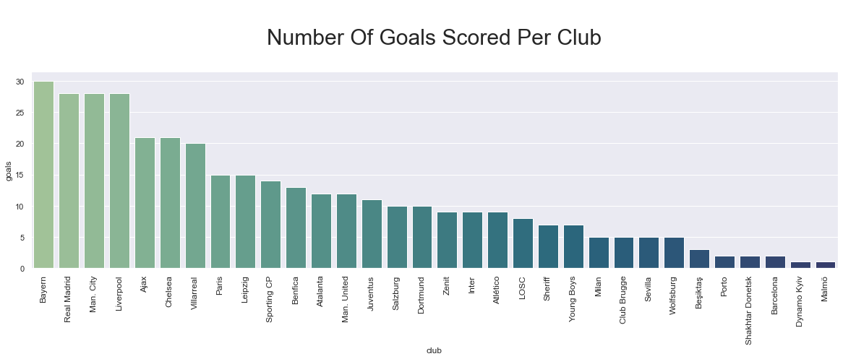

### Observations:

* Bayern scored most of the goals.
* The 2nd is the Champion Read Madrid.
* 3rd Manchester City was Semi-finalist

2. AVERAGE PLAYING TIME PER PLAYER PER CLUB (PLOT A GRAPH)

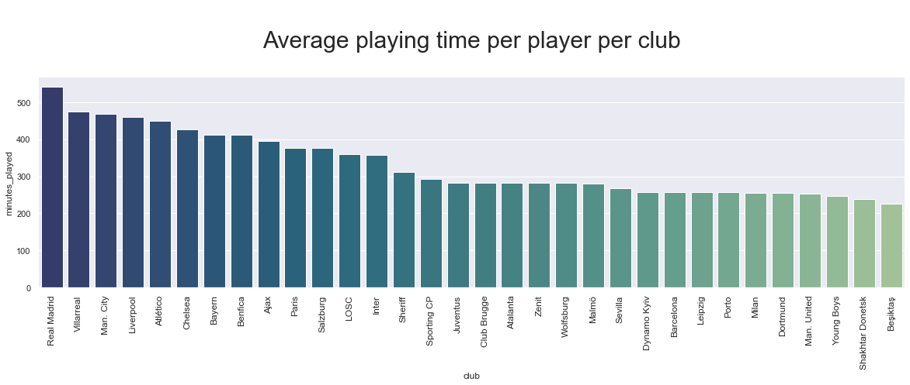

### Observations:

* As RMA is finalist and played 2 extra times, average laying time per player should be higher; but it is substantially higher than another finalist Liverpool (4th). So, the reason can be - RMA used less players in UCL, so each player had to play longer than usual.

### Suggestions:

* Playing time pressure should be reduced, and more player should be given place to perform.
* 3. PLOT AND RETURN A TABLE FOR TOP 10 SCORERS

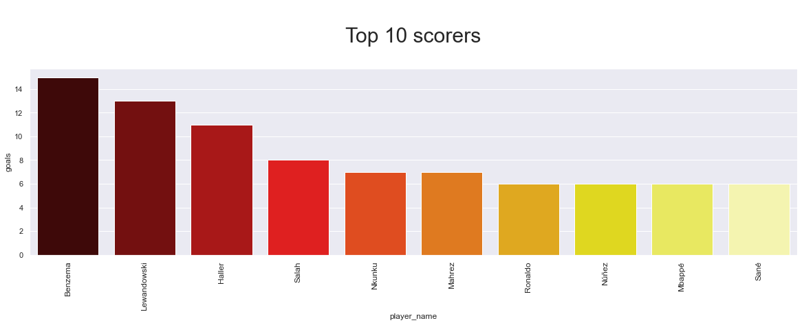

### Observations:

* Benzema from Champion Real Madrid scored Highest Number of goals.

### Insights

* Real Madrid dominance as a finalist. Other finalist Liverpool is staying behind in all stats.

4. TOP 15 TEAMS IN TERMS OF GOALS (PLOT A GRAPH AND TABLE)

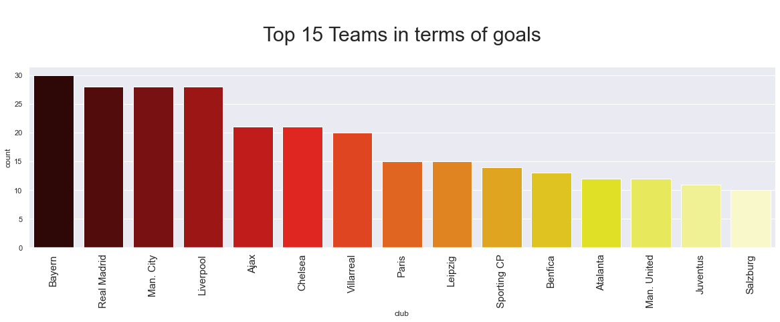

### Observations:

* Bayern leads the list; followed by two finalists

5. GOAL TYPES ANALYSIS (HOW SCORED: PLOT A GRAPH)

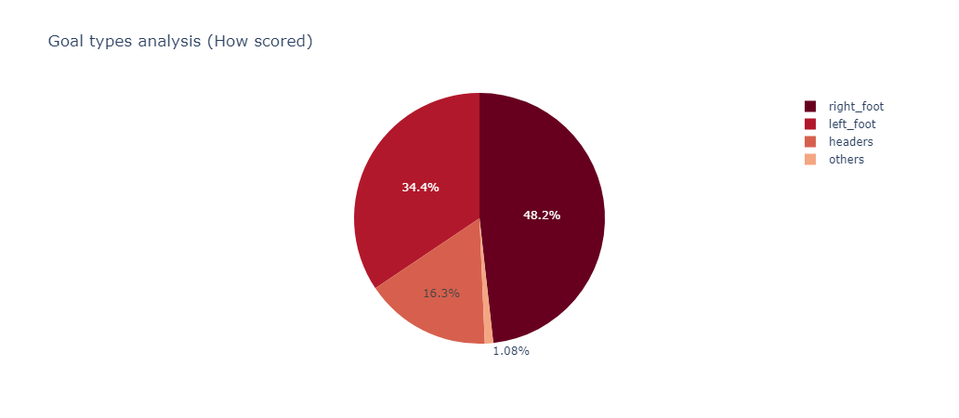

### Observations:

* Almost half of the goals are scored by right foot.
* the other half is almost 2/3 left foot and /3 headers

6. GOAL TYPES ANALYSIS (FROM WHERE SCORED: PLOT A GRAPH)

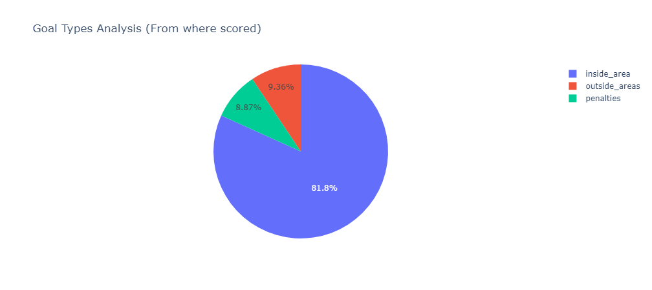

### Observations:

* Most goals are scored from inside the box.
* Outside of and penalties are about same.

7. GOAL TYPES ANALYSIS (PLAYER POSITION: PLOT A GRAPH)

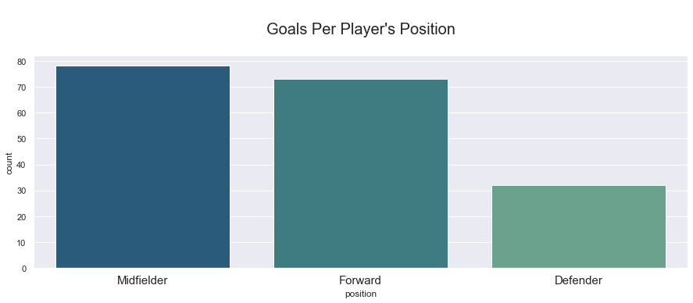

### Insights

* Midfielders scored more goals then forwards!!!

8. TOP 15 DRIBBLERS (PLOT A GRAPH)

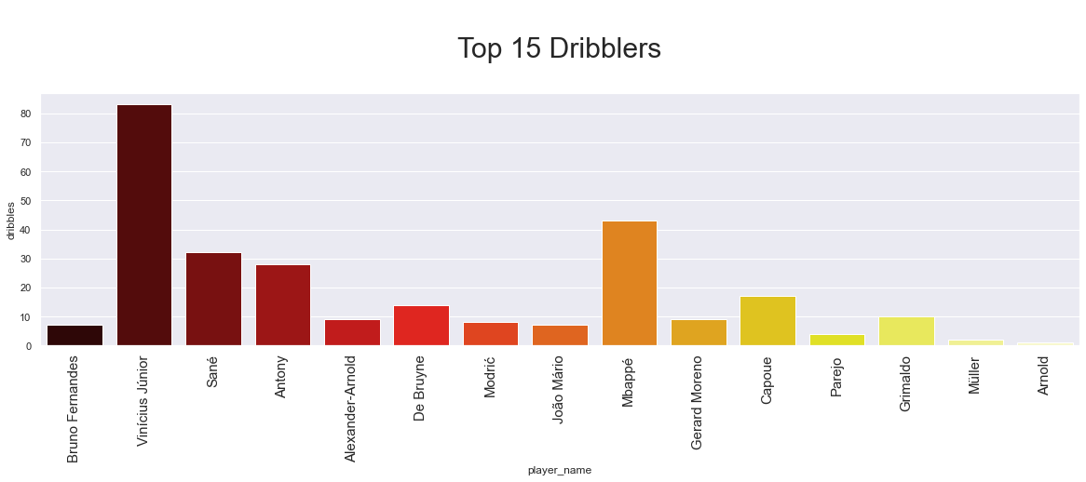

### Observations:

* Finalists leads the chart of the most dribbles by team.

9. TOP 15 CORNER TAKERS (PLOT A GRAPH)

